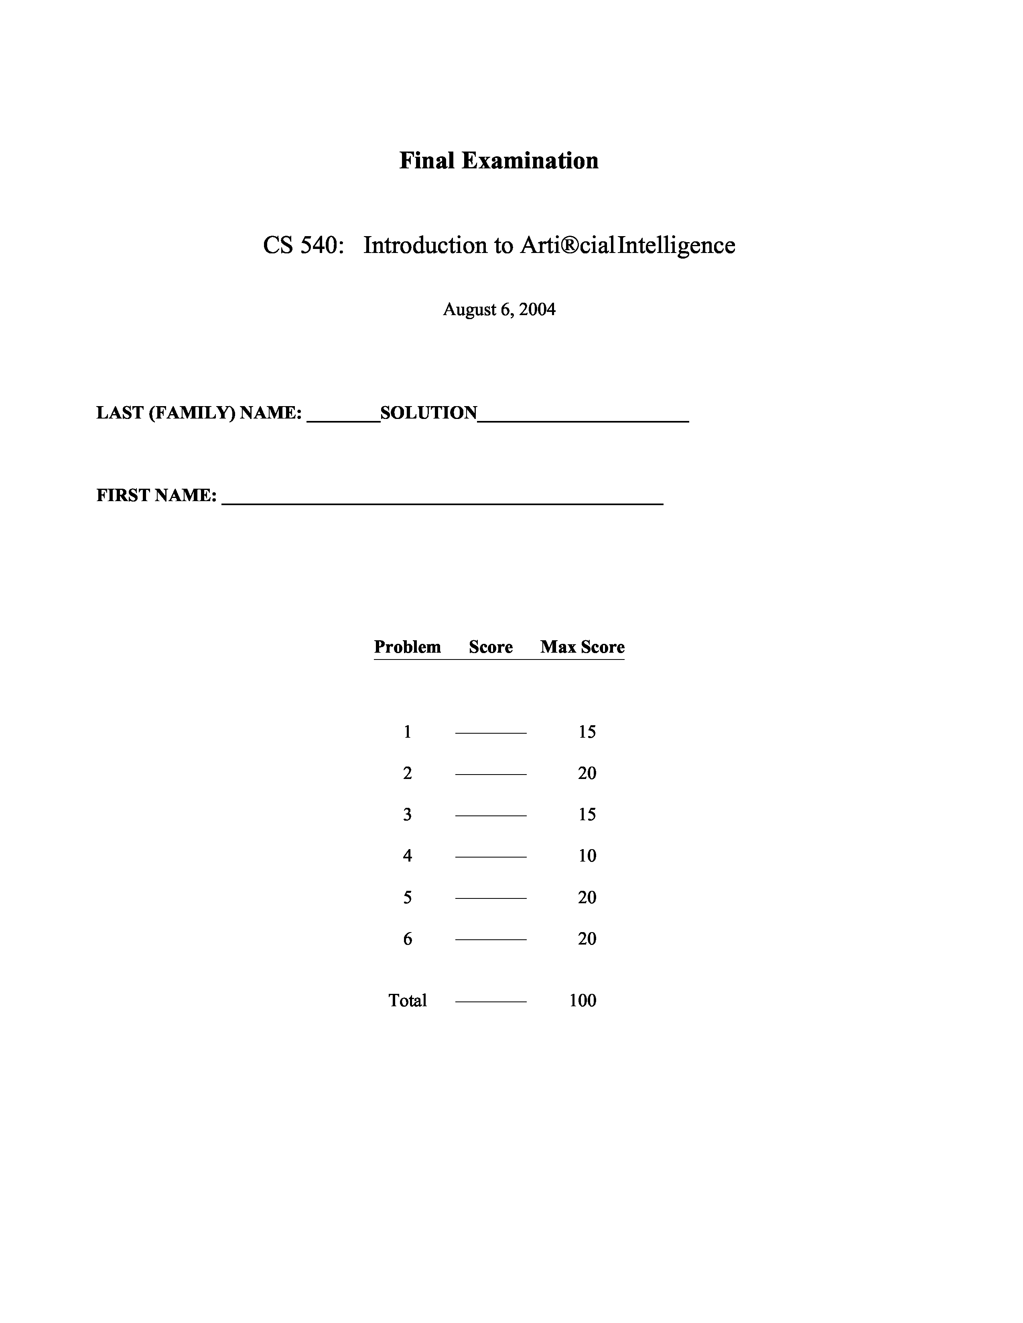
1. [15] Neural Networks
CS 540 Final Exam Summer 2004
(page 2 of 9)
- [4] The NAND function of n binary inputs, x1, x2, ..., x_{n} is definedas (x1 x2 . . . ^{x}n). Let True be represented by 1, False by 0, and n is a known, fixed constant. Can this function be represented by a Perceptron? If so, construct a Perceptron that does it; if not, argue why not.

Yes because it must output 0 only when all its inputs are 1s . A Perceptron that achieves this has all weights equal to -1 and the threshold at the single output unit equal to -n + 0.5.

- [4] The SAME function of two inputs, x1, x2, is definedto be 1 if the inputs are both the same (i.e., both 0 or both 1), and 0 otherwise. Can this function be represented by a Perceptron? If so, construct a Perceptron that does it; if not, argue why not.

No because this is not a linearly separable function.

- [4] Explain the difference in the Perceptron Learning Algorithm when a sigmoid activation function is used at the output units versus when a linear threshold unit (LTU) is used at the output units.

The weight update function differs in the Perceptron Learning Algorithm differs. For LTUs, w_{i} = (T O)x_{i} where T is the
desired output of the output unit, O is the actual output, is
the learning rate parameter, and x_{i} is the value of the ith input
unit. For the sigmoid function, w_{i} = (T O)O(1 O)x_{i} where the
extra term is the derivative of the sigmoid function.

- [3] When is a Support Vector Machine better to use than a Perceptron? Answer by describing characteristics of a specific situation that makes your point.

Perceptrons can only represent linearly separable functions, but SVMs can represent nonlinear functions by mapping the inputs into a higher dimensional space where the data is linearly separable. In addition, by maximizing the margin between the two classes, SVMs are usually more robust to noise and outliers than Perceptrons.
CS 540 Final Exam
Summer 2004
2. [20] Probabilistic Reasoning
Acute Pancreatitis (AP) is an acute inflammation of the pancreas that has multiple causes. Suppose that the prior probability of AP is 1 in 1,000 in a particular population. The blood serum level of amylase (AMY) is often one piece of information that is used in diagnosing AP. Assume AMY can be measured at just two levels, high and low. A high level of amylase is an indicator of AP. Suppose that from training data we know P(AMY=high | AP=true) = 0.95 and P(AMY=low | AP=false) = 0.98.
(a) [5] What is the false positive rate of using the level of amylase for diagnosing AP? That is, what percentage of the time would this test lead you to wrongly suspect AP in a patient? Write this in terms of P(... | ...) and then compute the answer.
P (AMY =high | AP =false)P (AP =false) ~ ~ ~ ~ ~ ~ ~ ~ ~ ~ ~ ~ ~ ~ ~ ~ ~ ~ ~ ~ ~ ~ ~ ~ ~ ~ ~ ~ ~ ~ ~ ~

P (AP =false | AMY =high) = P (AMY =high)
=
P (AMY =high | AP =false)P (AP =false)
~
~
~
~
~
~
~
~
~
~
~
~
~
~
~
~
~
~
~
~
~
~
~
~
~
~
~
~
~
~
~
~
~
~
~
~
~
~
~
~
~
~
~
~
~
~
~
~
~
~
~
~
~
~
~
~ ~
~
~
~
~
~
~
~ P (AMY =high | AP =false)P (AP =false)+P (AMY =high | AP =true)P (AP =true)
(1 0.98)(999/1000)
~
~
~
~
~
~
~
~
~
~
~
~
~
~
~
~ ~
~
~
~
~
~
~
~
~
~
~
~
~
~
~ (1 0.98)(999/1000)+(0.95)(1/1000)
= 0.955
So the false positive rate is 95.5%!
(b) [5] Compute P(AMY=high).
This is equal to the denominator in (a), so P(AMY=high) = 0.021.
(c) [5] Compute P(AP=true | AMY=high).
P (AP =true | AMY =high) = 1 P (AP =false | AMY =high) = 1 0.955 = 0.045
(d) [5] Show the full joint probability distribution table for this problem.
(page 3 of 9)
~ ~ ~ ~ ~
~ ~ ~ ~ ~ ~ ~ ~ ~ ~ ~ ~ ~ ~ ~ ~ ~ ~ ~ ~ ~
~
~ AP AMY P(AP, AMY)
~ ~ ~ ~
~ ~ ~ ~ ~ ~ ~ ~ ~ ~ ~ ~ ~ ~ ~ ~
~ ~ ~ ~ ~ ~ ~ ~ ~
~ ~
~ ~ ~ ~ ~ ~ ~ ~ ~ ~
~ ~ ~ ~ ~ ~ ~ ~
~ ~ ~ ~ ~ ~
~ ~ ~ ~
true high 0.00095
 | ~ ~ ~ ~ ~ ~ ~  ~ ~ | ~ ~ ~ ~ ~ ~ ~ | ~ ~ ~ ~ ~ ~ ~ ~ ~ ~ ~ ~ ~ ~
 | ~ true  ~ ~ ~ ~ ~  ~ ~ ~ | low ~  ~ ~ ~ ~ ~ ~ | 0.00005 ~  ~ ~ ~ ~ ~ ~ ~ ~ ~ ~ ~ ~ ~
 | false  ~ ~  ~ ~ ~ ~ ~ ~ ~ | ~ high  ~ ~ ~ ~ ~ ~ | 0.01998  ~ ~  ~ ~ ~ ~ ~ ~ ~ ~ ~ ~ ~ ~
 | false | low | 0.97902
~ ~ ~ ~
~ ~ ~ ~
~ ~ ~ ~ ~ ~ ~
~ ~ ~ ~ ~ ~ ~ ~ ~ ~ ~ ~ ~ ~ ~

Summer 2004
3. [15] Bayesian Networks
Consider a situation in which we want to reason about the relationship between the weather and traveling. We’ll use 3 Boolean random variables to represent "the Weather is bad" (W), "Airline flights between Madison and Chicago are cancelled" (A), and "automobile travel on Highway 90 between Madison and Chicago is delayed" (H).
Intuitively, we know that for any given weather condition, cancelled flights do not affect highway delays, and highway delays do not affect flight cancellations. From experience we know that if the weather is bad, there is an 80% chance that flights will be cancelled. If the weather is good, there is a 40% chance that flights will be cancelled. Furthermore, bad weather causes highway delays 30% of the time, but in good weather the chance of delays is 10%. There is a 20% chance of bad weather in Madison this time of year.
- [4] Create a Bayesian Network for this problem, including both the graph and the conditional probability tables.
P ( A, W, H) = P ( A | W,H) P (W,H)
= P ( A | W) P (H | W) P (W) = (0.2)(0.3)(0.2)
= 0.012
P (A,H) = P (A,H,W) + P (A,H, W)
= P (A | W)P (H | W)P (W) + P (A | W)P (H | W)P ( W) = (.8)(.3)(.2) + (.4)(.1)(.8)
= 0.048 + 0.032 = 0.08
P(A | ~W) = 0.4 P(H | W) = 0.3
A H
P(A | W) = 0.8
P(H | ~W) = 0.1
- [5] Compute P( A, W, H).
- [6] Compute P(A | H).
P (A,H)
~ ~
~
~
~
~
~
P (A | H) = P (H)
(page 5 of 9)

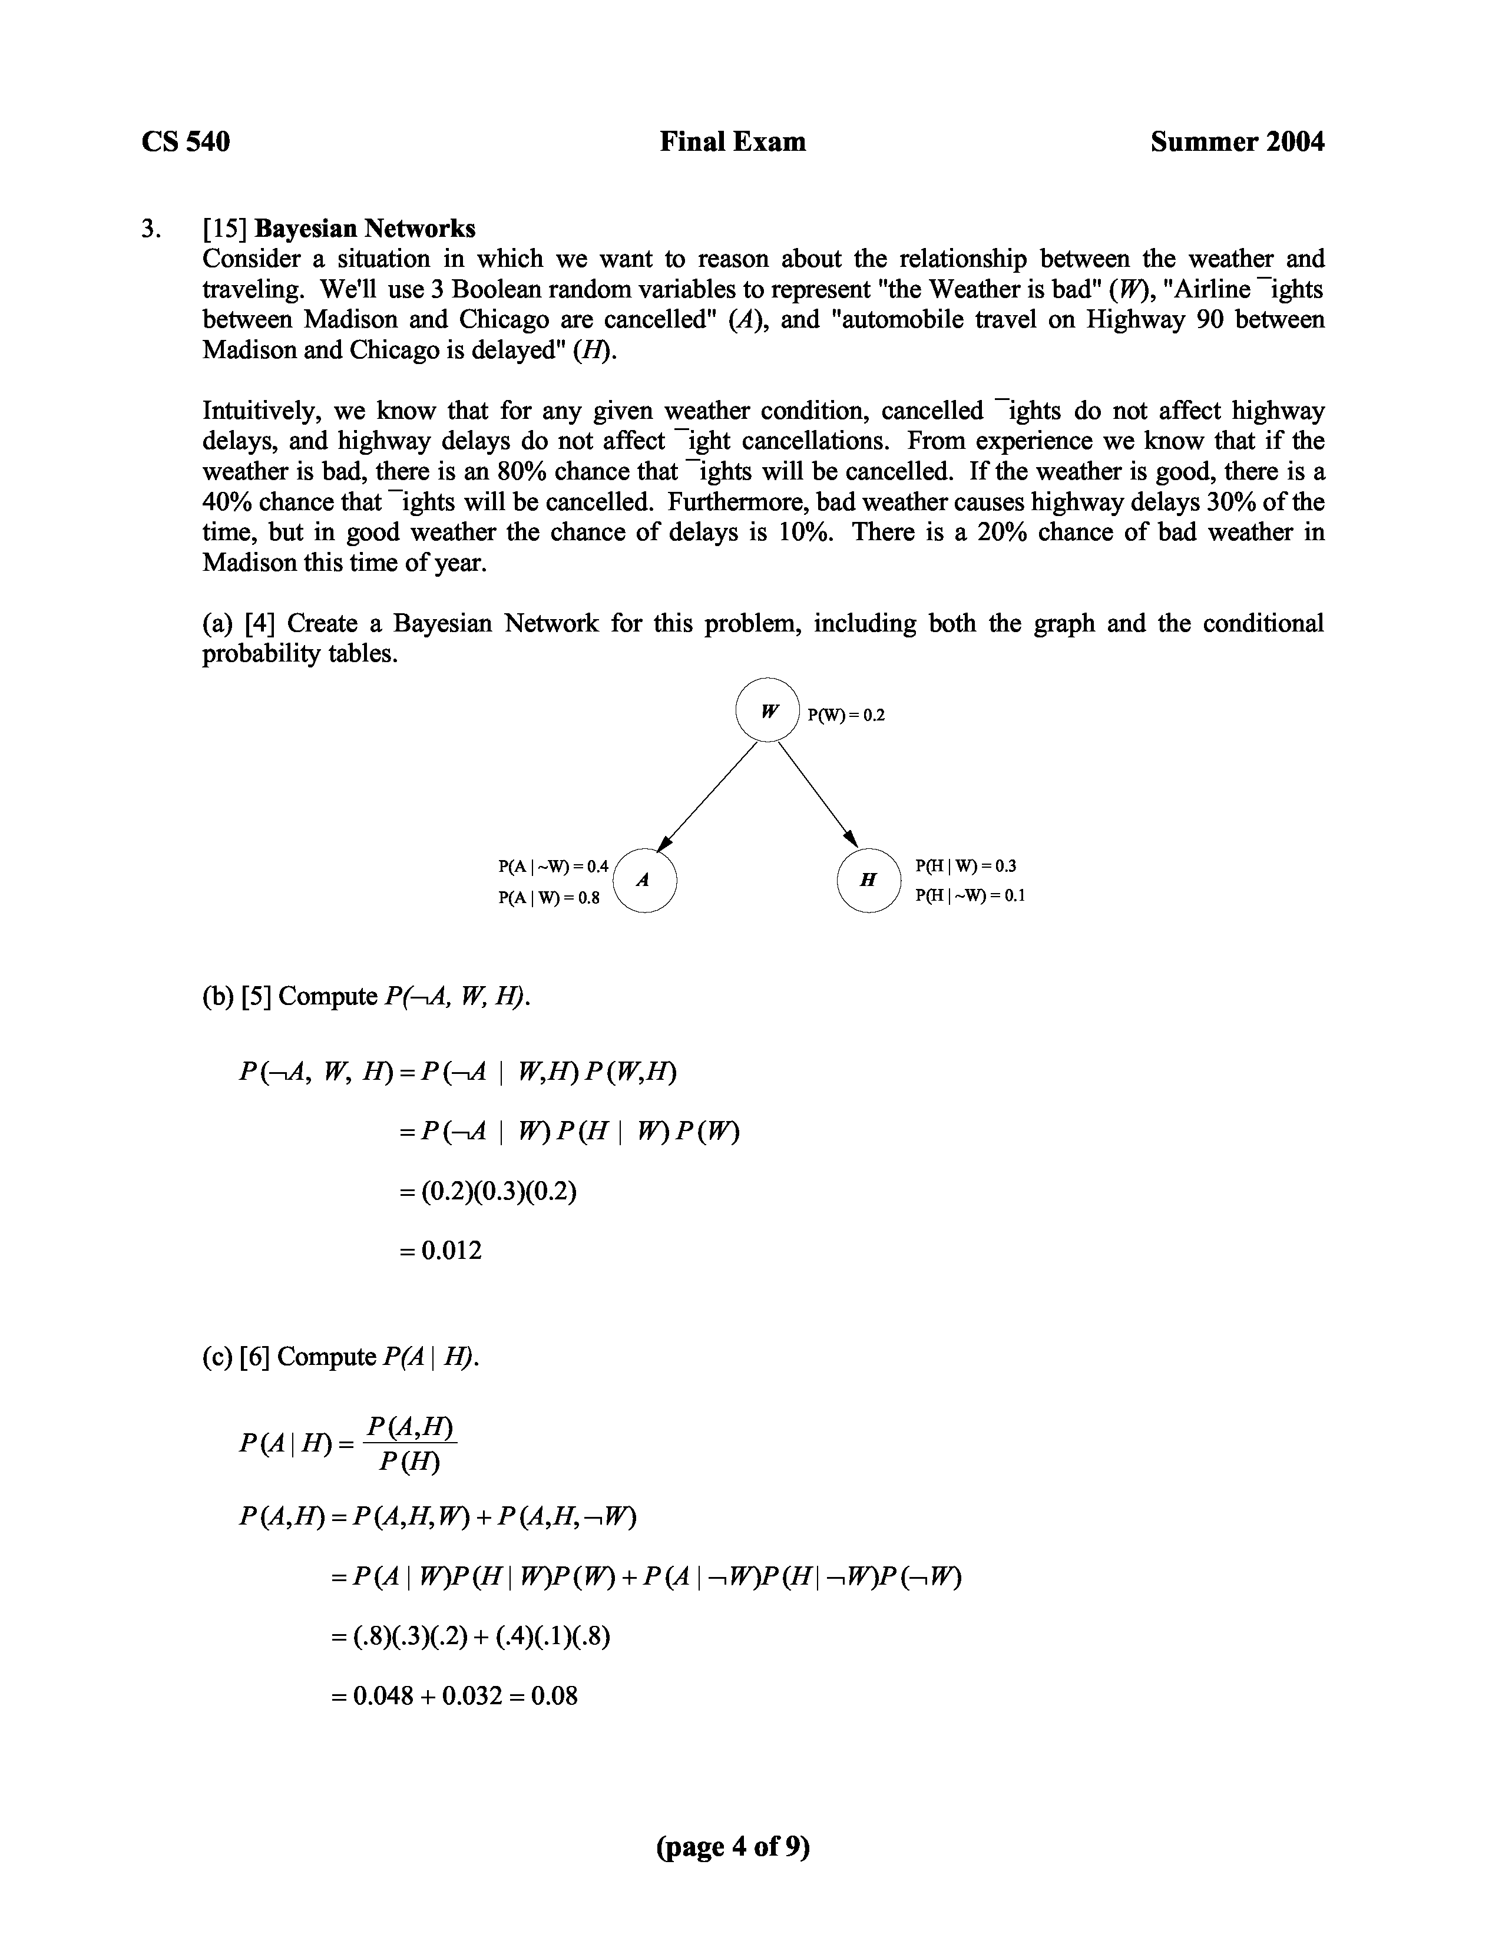
0.08
Summer 2004
CS 540 Final Exam
P (H) = P (H,A,W) + P (H,A, W) + P (H, A,W) + P (H, A, W)
= 0.08 + P ( A | W)P (H | W)P (W) + P ( A | W)P (H | W)P ( W) = 0.08 + (.2)(.3)(.2) + (.6)(.1)(.8)
= 0.14
(page 6 of 9)
~ ~ ~ ~
So, P (A | H) = 0.14 ~ = 0.57
4. [10] Situation Calculus
CS 540 Final Exam Summer 2004
(page 8 of 9)
Consider a domain where playing cards are manipulated in various ways, and one of the actions is to Flip a card over, i.e., if a card is face down, then Flip results in the card being face up; and if a card is face up, then Flip results in it being face down.

- [3] We want to use predicates Card, FaceUp, and FaceDown for this domain. Which of these predicates should be fluents?

FaceUp and FaceDown should be fluents because they can change over time. Card is not a fluent because an object that’s a card will always be a card.

- [4] Using the given three predicates and one action, write a sentence in the Situation Calculus that describes the act of flipping a card from face down to face up.
s,c (Card (c) FaceDown (c, s)) FaceUp (c, Result (Flip (c), s))
- [3] Would your sentence in (b) require one or more additional frame axioms to completely specify the Flip action? Explain why or why not.

Yes, it does require a frame axiom in order to say that all other cards do not change in any way when flipping the given card.
5. [20] Partial-Order Planning
CS 540 Final Exam Summer 2004
(page 9 of 9)
- [4] The POP algorithm makes choices at various stages of its execution. One choice is made when selecting which open precondition to solve next. What are two other choice points?

Three choice points are (1) whether to use simple establishment or step addition to satisfy an open precondition, (2) when step addition is used, which operator should be chosen if many are applicable to satisfy a given open precondition, and (3) whether to resolve a threat by promotion or demotion.

- [16] Suppose there is a bomb in your bathroom. The bomb is armed and the toilet is unclogged. Your goal is to disarm the bomb and have the toilet be unclogged. The only way to disarm the bomb is to dunk it in the toilet, provided the toilet is unclogged. Dunking the bomb in the toilet causes the toilet to be clogged. A clogged toilet can be unclogged by flushing it.

We can formulate this problem using two binary variables, Clogged and Armed. Initially, we have Clogged and Armed. The goal is Clogged and Armed. We’ll use the following two STRIPS-type operators:
DUNK FLUSH
Preconditions: Clogged Preconditions: --
Effects: Armed, Clogged Effects: Clogged
Starting from the initial plan for this problem, apply a sequence of the POP algorithm’s plan modification operations that results in a complete plan (i.e., one with no open preconditions and no threats). Draw the final plan using the following notation: Draw steps as boxes with the name of the operator inside. Above the box list the preconditions and below the box list the effects. If there are any threats that had to be resolved, explain what threatened what and how it was resolved.

The step Dunk threatened the causal link from Flush to Finish, and this was fixed by Demotion.
Start
~Clogged Armed
~Clogged ~Armed

Finish
Flush

6. [20] Markov Models and Hidden Markov Models
CS 540 Final Exam Summer 2004
(page 10 of 9)
- [5] A high school student has three possible outcomes for each school year: dropping out with probability d, repeating that year with probability r, and advancing to the next year with probability a. There are 4 years in high school, after which the student graduates. Draw a Markov Model for this situation, including definingthe states, show all possible transitions with probabilities where possible, and specify any constraints on the parameters in this model.
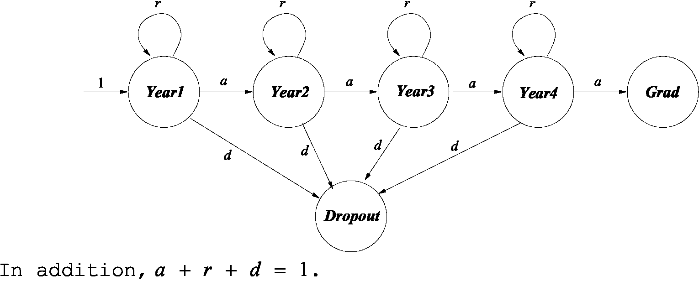
- [15] Consider a simplifiedversion of the "weather" Hidden Markov Model (HMM) presented in the paper by E. Fosler-Lussier. For this problem, assume the weather can be either sunny (S) or rainy (R) each day, each with prior probability 0.5. From one day to the next, the weather stays the same with probability 0.8 and changes with probability 0.2. On a sunny day, the probability that you will observe the caretaker carrying an umbrella (U) is 0.2, and on a rainy day it is 0.7. The prior probability that the caretaker carries an umbrella on any given day is 0.5. The weather outside is hidden to you and only the presence or absence of an umbrella each day is observed.

(i) [5] Draw the HMM. Include hidden states, observable values, vector, and label all arcs with probabilities.
The hidden states are Sunny and Rainy, the observable states (values) are U and U. The vector is shown with the probabilities on the arcs out of the Start state .
- [5] If on the first day you observe no umbrella, what is the chance that the weather that day is rainy? In other words, compute P (w1 = R | u1 = U). (Hint: Use the product rule.)
=
Note: Many people used P ( U) = 0.5 as the denominator though, as in the homework, this is not correct. Because of confusion about this in the homework without time to go over it in class, I accepted use of this value for this question.
- [5] What is the probability of seeing no umbrella on the first day, and seeing an umbrella on the second day, and the first day is rainy, and the second day is sunny? That is, compute P (u1 = U, u2 = U, w1 = R, w2 = S).
P (u1 = U, u2 = U, w1 = R, w2 = S) = P (S | R) P (R) P ( U | R) P (U | S) = (0.2)(0.5)(0.3)(0.2) = 0.006
P (R, U)
~
~
~
~
~
~
~
~ ~ P (w1=R | u 1 = U) = P ( U)
(0.3)(0.5)
~ ~ ~ ~ ~ ~ ~ ~ ~ ~ ~ ~ ~ ~ ~ ~ ~ ~
(0.3)(0.5) + (0.8)(0.5)
= 0.27
(page 11 of 9)

Summer 2004
CS 540 Final Exam
